System Design Document: Quad Transimpedance Amplifier

Rich Rademacher, University of Waterloo/IQC

March 2018

# Purpose

This document is both a system design document and design guide for a 4-channel transimpedance amplifier. This document will describe the basic requirements for a device to convert photodiode current into measurable voltage for use in oscilloscopes and other measurements.

# Requirements

This circuit is designed to:

* Provide 4 channels of current-to-voltage conversion
* Allow powering from +5VDC to +15VDC via RCA connectors
* Allow powering from 9V battery
* Switch between 10MHz, 1MHz and 100kHz output low-pass filter
* Drive a 50-ohm load
* Switch between 1V/A, 1 V/mA and 1 V/uA
* Provide a metal box that allows shielding
* Provide input and output from SMA connectors
* Support for photoconductive and photovoltaic mode

# Basic Circuit Design

The photodiode outputs a current proportional to voltage. The transimpedance amplifier is an op-amp circuit that converts input current to voltage. The basic circuit is shown below

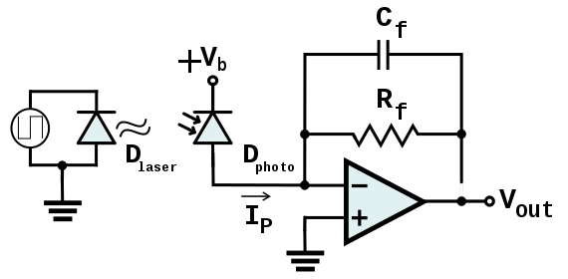

Figure Simple Transimpedance Amplifier

## Op-Amp Basics

The op-amp is a high-gain differential amplifier, meaning it amplifies the difference in voltage difference between its two input terminals. The use of feedback allows a large number of useful circuits to be constructed. Among the simplest is the inverting amplifier, shown below.

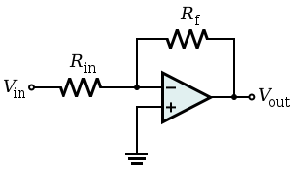

Figure Inverting Amplifier

The inverting amplifier is so named because of the feedback resistor Rf connected to the inverting input (-). In this configuration, the amplifier output Vout is driven until the voltage between the inverting (V-) and noninverting (V+) is zero. To show this, consider the amplifier’s open-circuit gain to be Av and is very large. The output voltage is then

$$V_{out}=A_{v}(V_{+}-V_{-})$$

Since the noninverting input V+ is grounded, the output is now

$$V_{out}={-A}_{v}V_{-}$$

The following conditions will be discussed: 1) Under stability conditions, the differential voltage V+ - V- is zero, and 2) the inputs of the amplifier are high-impedance, meaning no current flows into these terminals. The first condition solves for the current flowing through the input resistor Rin­.

The second condition ensures that this current also flows through the feedback resistor, and thus dictates the voltage across the feedback resistor.

$$V_{f}=\left(V_{out}-V_{-}\right)={-I}_{in}R_{f}$$

$$V_{out}={-V}_{in}\frac{R_{f}}{R_{in}}$$

The gain is simply the ratio Vout/Vin:

Thus, the inverting amplifier has a gain given by the ratio of the input and feedback resistor. Note that the feedback operates in ‘current mode’, meaning the output is dictated by a current. This will become important in the design of filters.

## Transimpedance Amplifier

The transimpedance amplifier is simply the inverting amplifier without the input resistance. In this case the current Iin that determines the output voltage is given directly by the attached device. In this case the output/input relation is between output voltage and input current, thus the units are impedance. Hence the name transimpedance.

$$\frac{V_{out}}{I_{in}}={-R}_{f}$$

## Applying Filtering

The feedback resistor *Rf* determines the circuit gain. If the resistance were frequency-dependent, the gain is also. Capacitors have a frequency-dependent reactance, decreasing impedance with increasing frequency. While part of the feedback circuit, any circuit elements are effectively isolated from the input device, and the output load. Since the feedback elements operate in current mode, an effective R-C low-pass network is given by a resistor *Rf* and capacitor *Cf* in parallel, and the cutoff is given by

$$F_{c}=R_{f} C_{f}/2π$$

The resulting circuit is shown below.

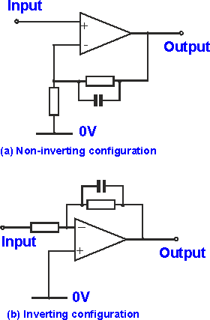

Figure Inverting low-pass filter

## Adding Bias

The negative sign in the gain equation for the transimpedance amplifier creates a problem: the op-amp requires a both positive- and negative supplies. Designing these can be expensive, and not truly necessary since the current through the diode will always be positive (since light intensity is always positive). We would like to improve this.

Recall the two terminals of the op-amp. Previously the noninverting input V+ was grounded. If this input is given a voltage Vbias, then by condition (2) above, the feedback will have a DC offset on it. Careful attention to signs shows that

$$V_{out}=V_{bias}-\frac{R_{f}}{R_{in}}V_{in}$$

For the transimpedance amplifier, the fixed bias voltage requires a steady bias current to flow. This can be used to operate a photodiode in its linear region.

A Zener diode D2 operated in reverse can provide an effective and cheap bias voltage. The voltage across the Zener is nearly constant regardless of variations in the voltage supply. The minimum current Ib through the Zener is given by the Zener manufacturer. A limiting resistor RB sets the current through D2.

The Zener reference can be prone to noise. Noise spread across frequencies and can be reduced with a simple capacitor across the Zenerdiode, which creates a low-pass filter on Vbias. The final result is shown below for a +5VDC supply.

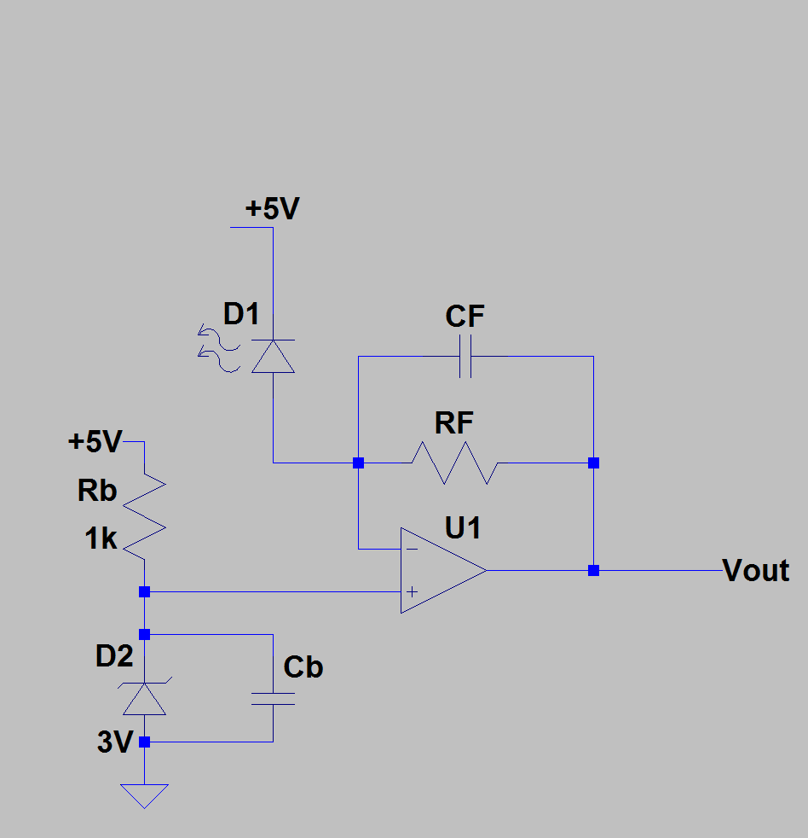

Figure Completed Transimpedance Amplifier